**SCD Lab 03**

**Name:** Hafsa Salman

**Roll no.** 22K-5161

**Task no. 01**

Code:

//Hafsa Salman  
//22K-5161  
//Task no. 01  
  
import javax.swing.*;  
import java.awt.event.ActionEvent;  
import java.awt.event.ActionListener;  
  
public class Task_01 extends JFrame  
{  
 private JPanel Task_01;  
 private JLabel Name;  
 private JTextField NameTxt;  
 private JLabel Grade;  
 private JComboBox GradeCombo;  
 private JLabel Activities;  
 private JCheckBox Box_01;  
 private JCheckBox Box_02;  
 private JCheckBox Box_03;  
 private JButton btn;  
  
 String str;  
  
 public Task_01()  
 {  
 btn.addActionListener (new ActionListener()  
 {  
 @Override  
 public void actionPerformed(ActionEvent e)  
 {  
 if (Box_01.isSelected())  
 {  
 str = Box_01.getText();  
 }  
  
 if (Box_02.isSelected())  
 {  
 str = Box_02.getText();  
 }  
  
 if (Box_03.isSelected())  
 {  
 str = Box_03.getText();  
 }  
  
 JOptionPane.*showMessageDialog*(btn, "Student Name: " + NameTxt.getText() + "\nGrade: " + GradeCombo.getSelectedItem() + "\nActivities: " + str);  
 }  
 });  
 }  
  
 public static void main(String[] args)  
 {  
 Task_01 T = new Task_01();  
  
 T.setContentPane(T.Task_01);  
 T.setTitle("Registration Form (22K-5161)");  
 T.setSize(400, 300);  
 T.setVisible(true);  
  
 T.setDefaultCloseOperation(JFrame.*EXIT_ON_CLOSE*);  
 }  
}

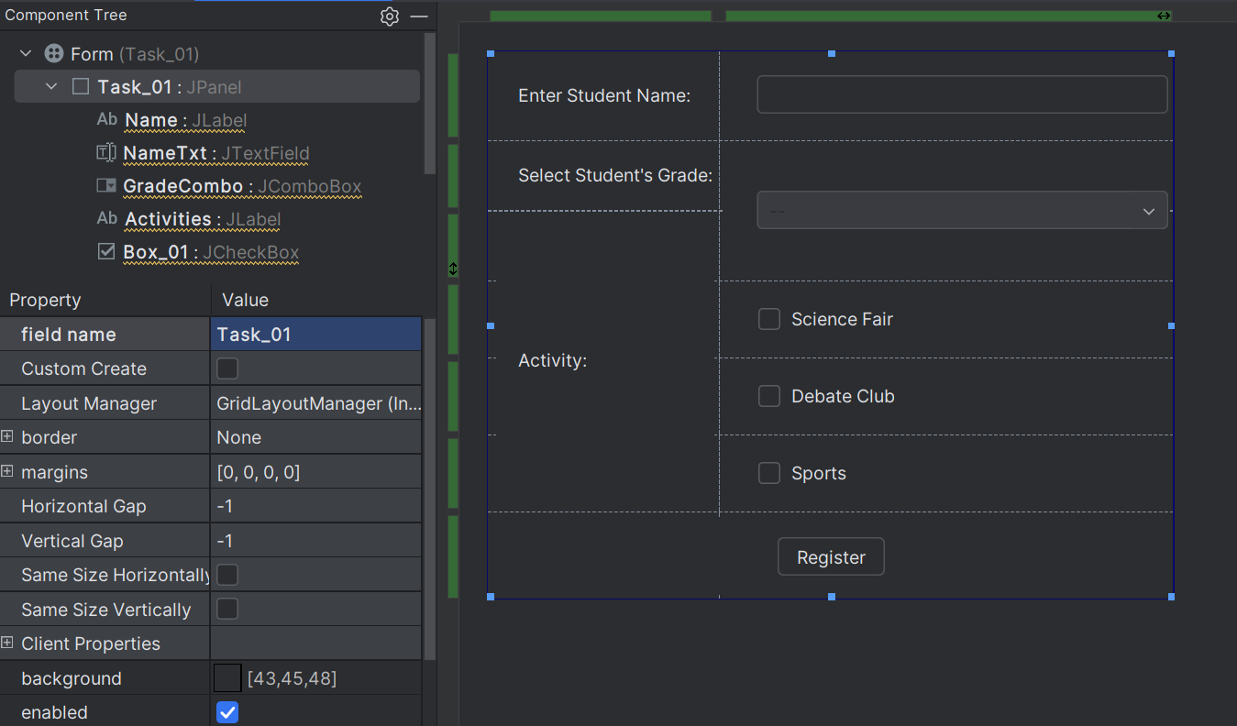

Output:

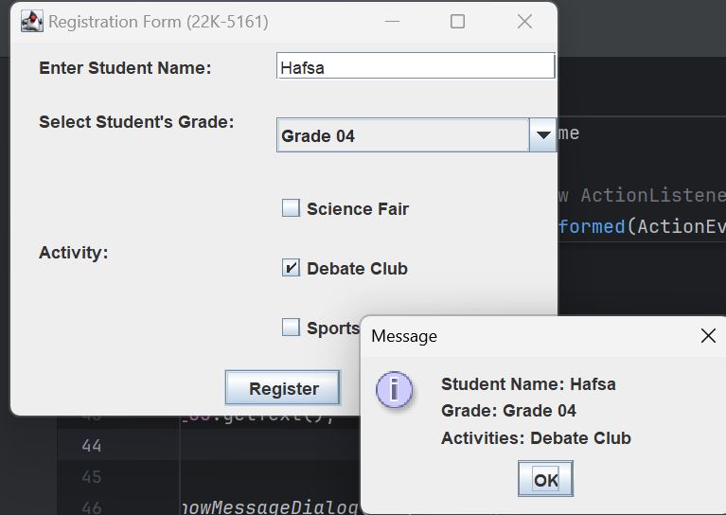

**Task no. 02**

Code:

//Hafsa Salman  
//22K-5161  
//Task no. 02  
  
import javax.swing.*;  
import java.awt.event.ActionEvent;  
import java.awt.event.ActionListener;  
  
public class Task_02 extends JFrame  
{  
 private JPanel Task_02;  
 private JLabel SearchBar;  
 private JTextField SearchTxt;  
 private JButton btn;  
 private JTextArea Area1;  
  
 public Task_02 ()  
 {  
 btn.addActionListener(new ActionListener()  
 {  
 @Override  
 public void actionPerformed (ActionEvent e)  
 {  
 JOptionPane.*showMessageDialog*(btn, "Search Term: " + SearchTxt.getText() + "\nResult: " + "\n1. JAVA Programming \n2.C Programming \n3. C++ Programming");  
 }  
 });  
 }  
  
 public static void main(String[] args)  
 {  
 Task_02 T2 = new Task_02();  
  
 T2.setContentPane(T2.Task_02);  
 T2.setTitle("Library Book Form (22K-5161)");  
 T2.setSize(400, 300);  
 T2.setVisible(true);  
  
 T2.setDefaultCloseOperation(JFrame.*EXIT_ON_CLOSE*);  
 }  
}

Output:

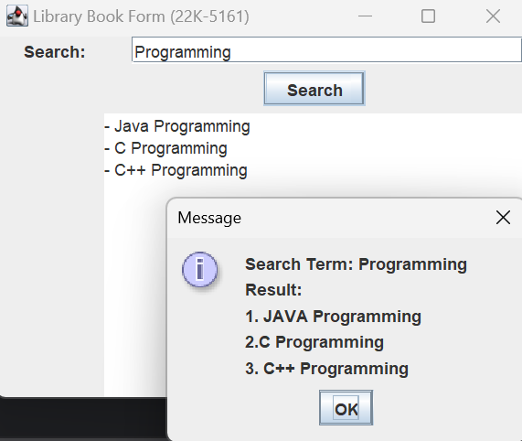

**Task no. 03**

Code:

//Hafsa Salman  
//22K-5161  
//Task no. 03  
  
import javax.swing.*;  
import java.awt.event.ActionEvent;  
import java.awt.event.ActionListener;  
  
public class Task_03 extends JFrame  
{  
 private JPanel Task_03;  
 private JLabel Name;  
 private JTextField Pname;  
 private JLabel CF;  
 private JTextArea Comments;  
 private JComboBox Rate;  
 private JLabel RateEvent;  
 private JButton btn;  
  
 public Task_03() {  
 btn.addActionListener(new ActionListener()  
 {  
 @Override  
 public void actionPerformed(ActionEvent e)  
 {  
 JOptionPane.*showMessageDialog*(btn, "Thank You, " + Pname.getText() + "!" + "\nRate: " + Rate.getSelectedItem().toString() + "\nFeedback: " + Comments.getText());  
 }  
 });  
 }  
  
 public static void main(String[] args)  
 {  
 Task_03 T3 = new Task_03();  
  
 T3.setContentPane(T3.Task_03);  
 T3.setTitle("Feedback Form (22K-5161)");  
 T3.setSize(400, 300);  
 T3.setVisible(true);  
  
 T3.setDefaultCloseOperation(JFrame.*EXIT_ON_CLOSE*);  
 }  
}

Output:

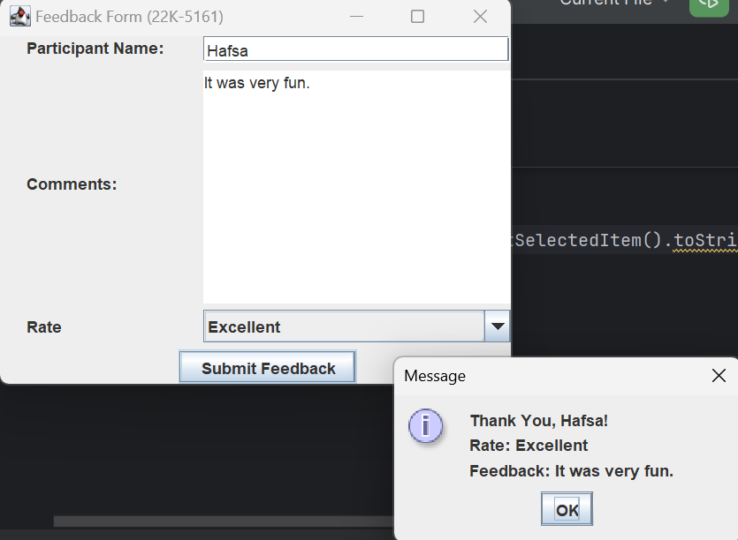

**Task no. 04**

Code:

//Hafsa Salman  
//22K-5161  
//Task no. 04  
  
import javax.swing.*;  
import java.awt.event.ActionEvent;  
import java.awt.event.ActionListener;  
import java.util.Objects;  
  
public class Task_04 extends JFrame  
{  
 private JPanel Task_04;  
 private JLabel Username;  
 private JTextField UsernameTxt;  
 private JLabel Password;  
 private JButton btn;  
 private JPasswordField PasswordTxt;  
  
 public Task_04()  
 {  
 btn.addActionListener(new ActionListener()  
 {  
 @Override  
 public void actionPerformed(ActionEvent e)  
 {  
 char[] pass = PasswordTxt.getPassword();  
 String password = new String(pass);  
  
  
 if (Objects.*equals*(password, "12345") && Objects.*equals*(UsernameTxt.getText(), "Hafsa"))  
 {  
 JOptionPane.*showMessageDialog*(btn, "Login Successful!");  
 }  
  
 else  
 {  
 JOptionPane.*showMessageDialog*(btn, "Wrong Username or Password!");  
 }  
 }  
 });  
 }  
  
 public static void main(String[] args)  
 {  
 Task_04 T4 = new Task_04();  
  
 T4.setContentPane(T4.Task_04);  
 T4.setTitle("Login System (22K-5161)");  
 T4.setSize(400, 300);  
 T4.setVisible(true);  
  
 T4.setDefaultCloseOperation(JFrame.*EXIT_ON_CLOSE*);  
 }  
}

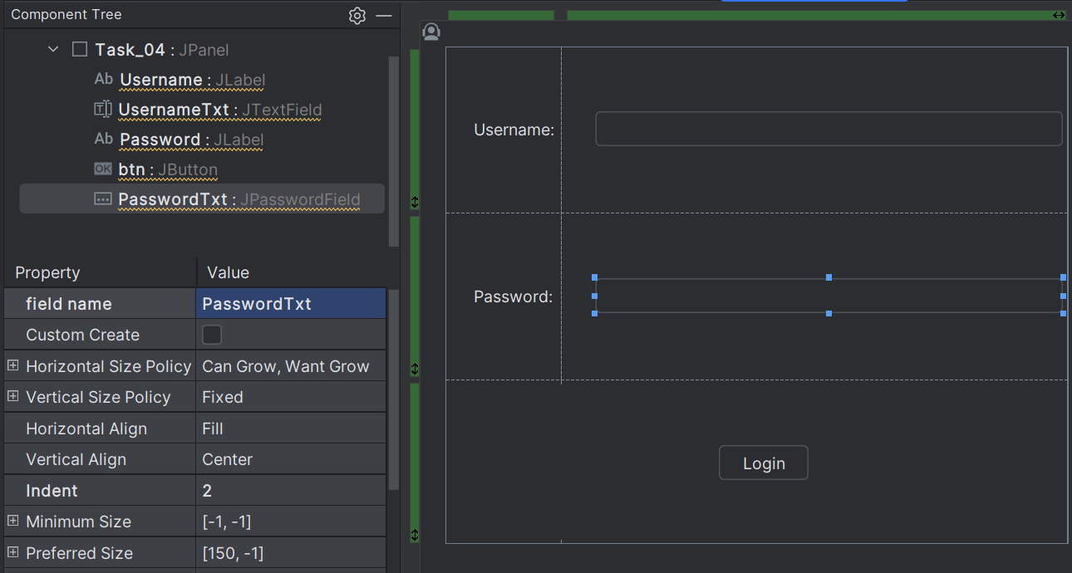

Output:

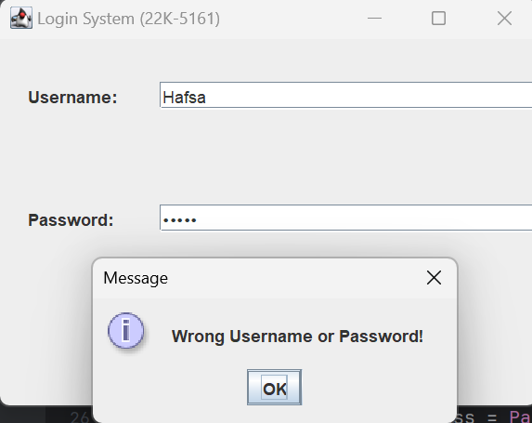

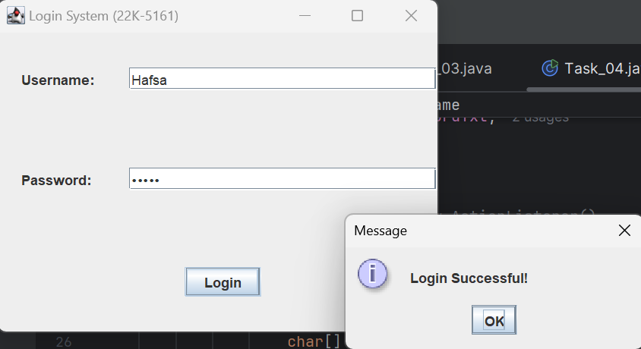

**Task no. 05**

Code:

//Hafsa Salman  
//22K-5161  
//Task no. 05  
  
import javax.swing.*;  
import java.awt.event.ActionEvent;  
import java.awt.event.ActionListener;  
  
public class Task_05 extends JFrame  
{  
 private JPanel Task_05;  
 private JLabel Name;  
 private JTextField NameTxt;  
 private JLabel Food;  
 private JComboBox FoodTxt;  
 private JLabel Quantity;  
 private JSpinner QuantityTxt;  
 private JButton btn;  
  
 public Task_05() {  
 btn.addActionListener(new ActionListener()  
 {  
 @Override  
 public void actionPerformed(ActionEvent e)  
 {  
 JOptionPane.*showMessageDialog*(btn, NameTxt.getText() + ", you have ordered " + QuantityTxt.getValue() + " " + FoodTxt.getSelectedItem() + ".");  
 }  
 });  
 }  
  
 public static void main(String[] args)  
 {  
 Task_05 T5 = new Task_05();  
  
 T5.setContentPane(T5.Task_05);  
 T5.setTitle("Order Form (22K-5161)");  
 T5.setSize(400, 300);  
 T5.setVisible(true);  
  
 T5.setDefaultCloseOperation(JFrame.*EXIT_ON_CLOSE*);  
 }  
}

Output:

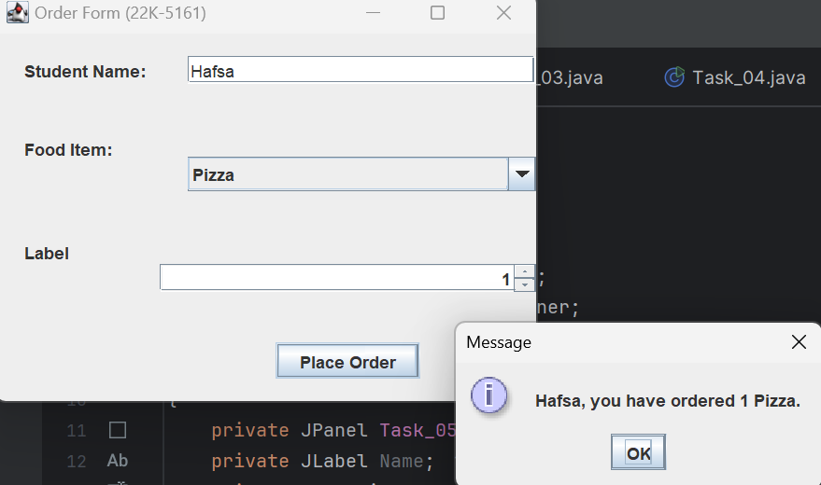

**Task no. 06**

Code:

//Hafsa Salman  
//22K-5161  
//Task no. 06  
  
import javax.swing.*;  
import java.awt.event.ActionEvent;  
import java.awt.event.ActionListener;  
import java.util.Objects;  
  
public class Task_06 extends JFrame  
{  
 private JPanel Login;  
 private JLabel Username;  
 private JTextField UsernameTxt;  
 private JPasswordField PasswordTxt;  
 private JLabel Password;  
 private JButton btn01;  
 private JLabel Logo;  
  
 public Task_06() {  
 btn01.addActionListener(new ActionListener()  
 {  
 @Override  
 public void actionPerformed(ActionEvent e)  
 {  
 char[] pass = PasswordTxt.getPassword();  
 String password = new String(pass);  
  
  
 if (Objects.*equals*(password, "12345") && Objects.*equals*(UsernameTxt.getText(), "Hafsa"))  
 {  
 Home home = new Home();  
 home.Print();  
 dispose();  
 }  
  
 else  
 {  
 JOptionPane.*showMessageDialog*(btn01, "Invalid Username or Password!");  
 }  
 }  
 });  
 }  
  
 public static void main(String[] args)  
 {  
 Task_06 T6 = new Task_06();  
  
 T6.setContentPane(T6.Login);  
 T6.setTitle("Flex Students (22K-5161)");  
 T6.setSize(600, 700);  
 T6.setVisible(true);  
  
 T6.setDefaultCloseOperation(JFrame.*EXIT_ON_CLOSE*);  
 }  
}

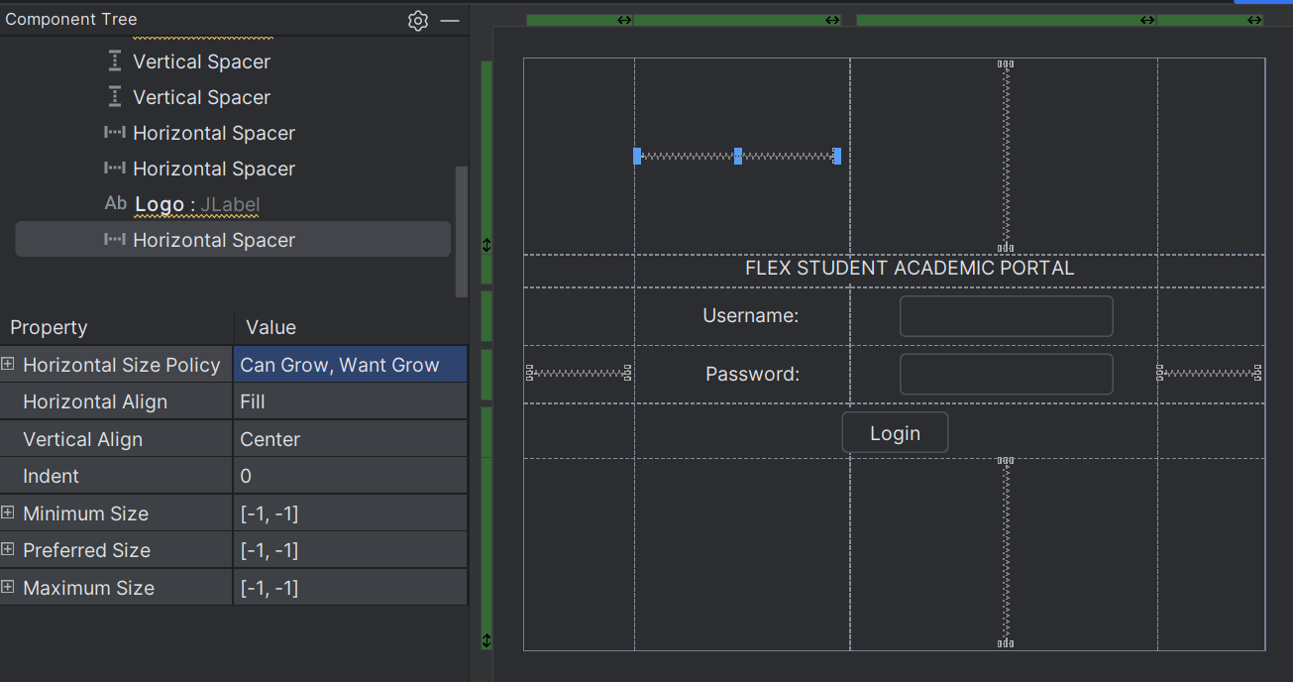

//Hafsa Salman  
//22K-5161  
//Task no. 06  
  
import javax.swing.*;  
import java.awt.event.ActionEvent;  
import java.awt.event.ActionListener;  
  
public class Home extends JFrame  
{  
 private JButton Home;  
 private JPanel HomePage;  
 private JButton CR;  
 private JButton Attend;  
 private JButton Marks;  
 private JButton Transcript;  
 private JButton FC;  
 private JButton CourseFeed;  
 private JButton RER;  
 private JButton CW;  
 private JButton GCR;  
 private JButton profileButton;  
 private JTextArea universityInformationTextArea;  
 private JTextArea academicCalendarTextArea;  
 private JTextArea contactInformationTextArea;  
 private JTextArea familyInformationTextArea;  
  
 public Home()  
 {  
 Home.addActionListener(new ActionListener()  
 {  
 @Override  
 public void actionPerformed(ActionEvent e)  
 {  
 Home home = new Home();  
 home.Print();  
 dispose();  
 }  
 });  
  
 CR.addActionListener(new ActionListener()  
 {  
 @Override  
 public void actionPerformed(ActionEvent e)  
 {  
 CourseRegistration cr = new CourseRegistration();  
 cr.Print();  
 dispose();  
 }  
 });  
  
 Attend.addActionListener(new ActionListener()  
 {  
 @Override  
 public void actionPerformed(ActionEvent e)  
 {  
 Attendance a = new Attendance();  
 a.Print();  
 dispose();  
 }  
 });  
  
  
 Marks.addActionListener(new ActionListener()  
 {  
 @Override  
 public void actionPerformed(ActionEvent e)  
 {  
 Marks m = new Marks();  
 m.Print();  
 dispose();  
 }  
 });  
  
 Transcript.addActionListener(new ActionListener()  
 {  
 @Override  
 public void actionPerformed(ActionEvent e)  
 {  
 Transcript t = new Transcript();  
 t.Print();  
 dispose();  
 }  
 });  
  
  
 FC.addActionListener(new ActionListener() {  
  
 @Override  
 public void actionPerformed(ActionEvent e)  
 {  
 FeeChallan fc = new FeeChallan();  
 fc.Print();  
 dispose();  
 }  
 });  
  
 CourseFeed.addActionListener(new ActionListener()  
 {  
 @Override  
 public void actionPerformed(ActionEvent e)  
 {  
 CourseFeedback cf = new CourseFeedback();  
 cf.Print();  
 dispose();  
 }  
 });  
  
 RER.addActionListener(new ActionListener()  
 {  
 @Override  
 public void actionPerformed(ActionEvent e)  
 {  
 RetakeExamRequest rer = new RetakeExamRequest();  
 rer.Print();  
 dispose();  
 }  
 });  
  
  
 GCR.addActionListener(new ActionListener()   
 {  
 @Override  
 public void actionPerformed(ActionEvent e)   
 {  
 GradeChangeRequest gcr = new GradeChangeRequest();  
 gcr.Print();  
 dispose();  
 }  
 });  
 }  
  
 public void Print()  
 {  
 Home T6 = new Home();  
 T6.setContentPane(T6.HomePage);  
 T6.setTitle("HomePage (22K-5161)");  
 T6.setSize(600, 700);  
 T6.setVisible(true);  
 T6.setDefaultCloseOperation(JFrame.*EXIT_ON_CLOSE*);  
 }  
  
 public static void main(String[] args)  
 {  
 Home T6 = new Home();  
  
 T6.setContentPane(T6.HomePage);  
 T6.setTitle("Home Page (22K-5161)");  
 T6.setSize(600, 700);  
 T6.setVisible(true);  
  
 T6.setDefaultCloseOperation(JFrame.*EXIT_ON_CLOSE*);  
 }  
  
}

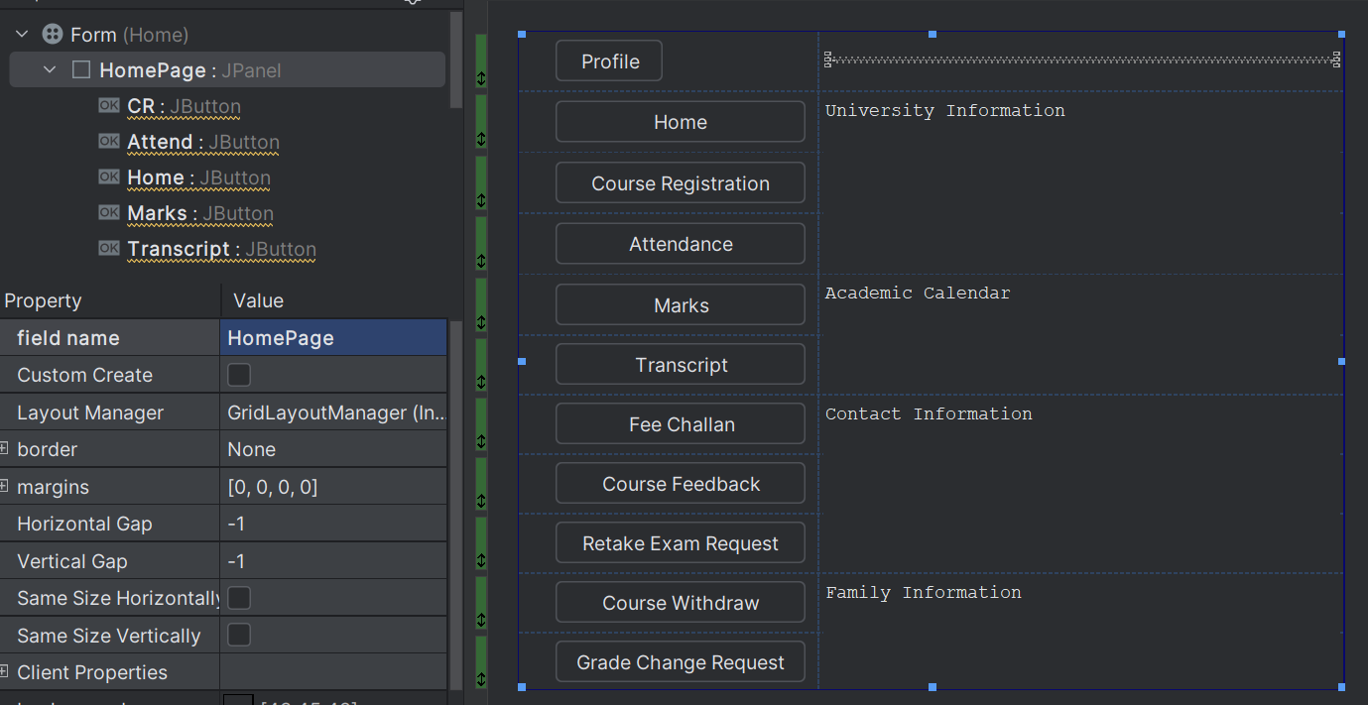

//Hafsa Salman  
//22K-5161  
//Task no. 06  
  
import javax.swing.*;  
import java.awt.event.ActionEvent;  
import java.awt.event.ActionListener;  
  
public class CourseRegistration extends JFrame  
{  
 private JButton profileButton;  
 private JButton homeButton;  
 private JButton courseRegistrationButton;  
 private JButton attendanceButton;  
 private JButton marksButton;  
 private JButton transcriptButton;  
 private JButton feeChallanButton;  
 private JButton courseFeedbackButton;  
 private JButton retakeExamRequestButton;  
 private JButton gradeChangeRequestButton;  
 private JTextArea courseRegistrationPeriodIsTextArea;  
 private JPanel CourseR;  
  
 public CourseRegistration() {  
 homeButton.addActionListener(new ActionListener()  
 {  
 @Override  
 public void actionPerformed(ActionEvent e)  
 {  
 Home home = new Home();  
 home.Print();  
 dispose();  
 }  
 });  
  
  
 courseRegistrationButton.addActionListener(new ActionListener()  
 {  
 @Override  
 public void actionPerformed(ActionEvent e)  
 {  
 CourseRegistration courseRegistration = new CourseRegistration();  
 courseRegistration.Print();  
 dispose();  
 }  
 });  
  
  
 attendanceButton.addActionListener(new ActionListener()  
 {  
 @Override  
 public void actionPerformed(ActionEvent e)  
 {  
 Attendance attendance = new Attendance();  
 attendance.Print();  
 dispose();  
 }  
 });  
  
  
 marksButton.addActionListener(new ActionListener()  
 {  
 @Override  
 public void actionPerformed(ActionEvent e)  
 {  
 Marks marks = new Marks();  
 marks.Print();  
 dispose();  
 }  
 });  
  
  
 transcriptButton.addActionListener(new ActionListener()  
 {  
 @Override  
 public void actionPerformed(ActionEvent e)  
 {  
 Transcript transcript = new Transcript();  
 transcript.Print();  
 dispose();  
 }  
 });  
  
  
 feeChallanButton.addActionListener(new ActionListener()  
 {  
 @Override  
 public void actionPerformed(ActionEvent e)  
 {  
 FeeChallan feeChallan = new FeeChallan();  
 feeChallan.Print();  
 dispose();  
 }  
 });  
  
  
 courseFeedbackButton.addActionListener(new ActionListener()  
 {  
 @Override  
 public void actionPerformed(ActionEvent e)  
 {  
 CourseFeedback courseFeedback = new CourseFeedback();  
 courseFeedback.Print();  
 dispose();  
 }  
 });  
  
  
 retakeExamRequestButton.addActionListener(new ActionListener()   
 {  
 @Override  
 public void actionPerformed(ActionEvent e)   
 {  
 RetakeExamRequest retakeExamRequest = new RetakeExamRequest();  
 retakeExamRequest.Print();  
 dispose();  
 }  
 });  
  
  
 gradeChangeRequestButton.addActionListener(new ActionListener()   
 {  
 @Override  
 public void actionPerformed(ActionEvent e)   
 {  
 GradeChangeRequest gradeChangeRequest = new GradeChangeRequest();  
 gradeChangeRequest.Print();  
 dispose();  
 }  
 });  
 }  
  
 public void Print()  
 {  
 CourseRegistration T6 = new CourseRegistration();  
 T6.setContentPane(T6.CourseR);  
 T6.setTitle("CourseRegistration (22K-5161)");  
 T6.setSize(600, 700);  
 T6.setVisible(true);  
 T6.setDefaultCloseOperation(JFrame.*EXIT_ON_CLOSE*);  
 }  
  
 public static void main(String[] args)  
 {  
 CourseRegistration T6 = new CourseRegistration();  
  
 T6.setContentPane(T6.CourseR);  
 T6.setTitle("Course Registration (22K-5161)");  
 T6.setSize(600, 700);  
 T6.setVisible(true);  
  
 T6.setDefaultCloseOperation(JFrame.*EXIT_ON_CLOSE*);  
 }  
}

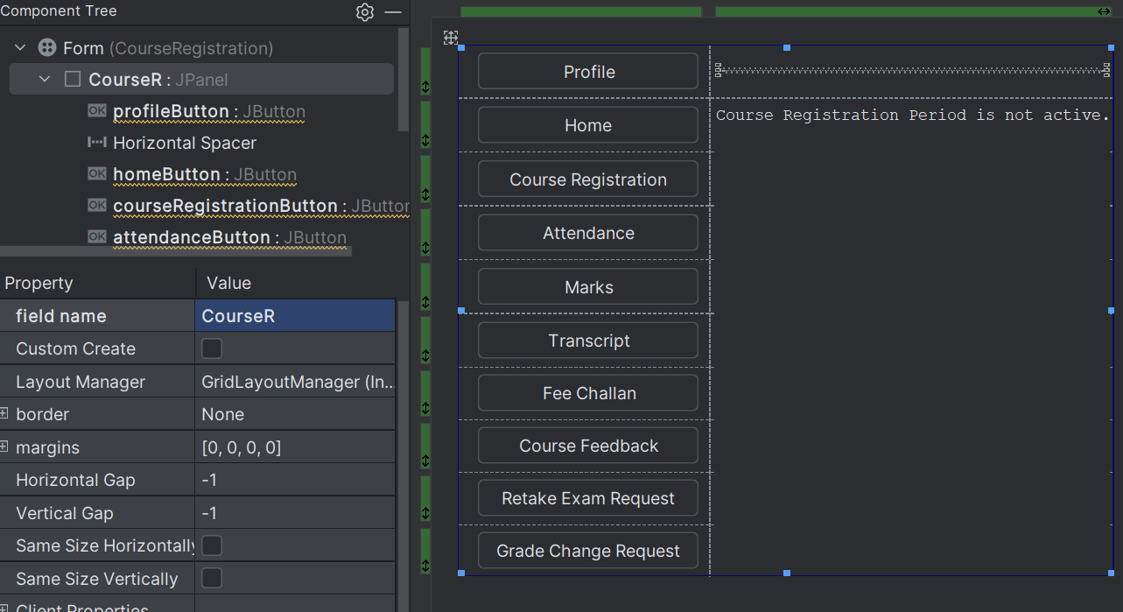

//Hafsa Salman  
//22K-5161  
//Task no. 06  
  
import javax.swing.*;  
import java.awt.event.ActionEvent;  
import java.awt.event.ActionListener;  
  
public class Attendance extends JFrame  
{  
 private JButton profileButton;  
 private JButton homeButton;  
 private JButton courseRegistrationButton;  
 private JButton attendanceButton;  
 private JButton marksButton;  
 private JButton transcriptButton;  
 private JButton feeChallanButton;  
 private JButton courseFeedbackButton;  
 private JButton retakeExamRequestButton;  
 private JButton gradeChangeRequestButton;  
 private JTextArea ATTENDANCETextArea;  
 private JTextArea attendanceHavenTBeenTextArea;  
 private JPanel Attend;  
  
  
 public Attendance()   
 {  
 homeButton.addActionListener(new ActionListener()   
 {  
 @Override  
 public void actionPerformed(ActionEvent e)   
 {  
 Home home = new Home();  
 home.Print();  
 dispose();  
 }  
 });  
  
 courseRegistrationButton.addActionListener(new ActionListener()  
 {  
 @Override  
 public void actionPerformed(ActionEvent e)  
 {  
 CourseRegistration courseRegistration = new CourseRegistration();  
 courseRegistration.Print();  
 dispose();  
 }  
 });  
  
  
 attendanceButton.addActionListener(new ActionListener()  
 {  
 @Override  
 public void actionPerformed(ActionEvent e)  
 {  
 Attendance attendance = new Attendance();  
 attendance.Print();  
 dispose();  
 }  
 });  
  
  
 marksButton.addActionListener(new ActionListener()  
 {  
 @Override  
 public void actionPerformed(ActionEvent e)  
 {  
 Marks marks = new Marks();  
 marks.Print();  
 dispose();  
 }  
 });  
  
  
 transcriptButton.addActionListener(new ActionListener()  
 {  
 @Override  
 public void actionPerformed(ActionEvent e)  
 {  
 Transcript transcript = new Transcript();  
 transcript.Print();  
 dispose();  
 }  
 });  
  
  
 feeChallanButton.addActionListener(new ActionListener()  
 {  
 @Override  
 public void actionPerformed(ActionEvent e)  
 {  
 FeeChallan feeChallan = new FeeChallan();  
 feeChallan.Print();  
 dispose();  
 }  
 });  
  
  
 courseFeedbackButton.addActionListener(new ActionListener()  
 {  
 @Override  
 public void actionPerformed(ActionEvent e)  
 {  
 CourseFeedback courseFeedback = new CourseFeedback();  
 courseFeedback.Print();  
 dispose();  
 }  
 });  
  
  
 retakeExamRequestButton.addActionListener(new ActionListener()  
 {  
 @Override  
 public void actionPerformed(ActionEvent e)  
 {  
 RetakeExamRequest retakeExamRequest = new RetakeExamRequest();  
 retakeExamRequest.Print();  
 dispose();  
 }  
 });  
  
  
 gradeChangeRequestButton.addActionListener(new ActionListener()  
 {  
 @Override  
 public void actionPerformed(ActionEvent e)  
 {  
 GradeChangeRequest gradeChangeRequest = new GradeChangeRequest();  
 gradeChangeRequest.Print();  
 dispose();  
 }  
 });  
 }  
  
 public void Print()  
 {  
 Attendance T6 = new Attendance();  
 T6.setContentPane(T6.Attend);  
 T6.setTitle("Attendance (22K-5161)");  
 T6.setSize(600, 700);  
 T6.setVisible(true);  
 T6.setDefaultCloseOperation(JFrame.*EXIT_ON_CLOSE*);  
 }  
  
 public static void main(String[] args)  
 {  
 Attendance T6 = new Attendance();  
  
 T6.setContentPane(T6.Attend);  
 T6.setTitle("Attendance (22K-5161)");  
 T6.setSize(600, 700);  
 T6.setVisible(true);  
  
 T6.setDefaultCloseOperation(JFrame.*EXIT_ON_CLOSE*);  
 }  
}

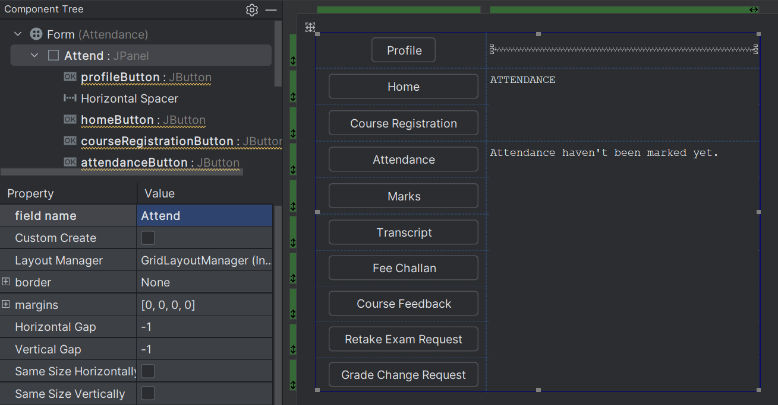

//Hafsa Salman  
//22K-5161  
//Task no. 06  
  
import javax.swing.*;  
import java.awt.event.ActionEvent;  
import java.awt.event.ActionListener;  
  
public class Marks extends JFrame  
{  
 private JButton profileButton;  
 private JButton homeButton;  
 private JButton courseRegistrationButton;  
 private JButton attendanceButton;  
 private JButton marksButton;  
 private JButton transcriptButton;  
 private JButton feeChallanButton;  
 private JButton courseFeedbackButton;  
 private JButton retakeExamRequestButton;  
 private JButton gradeChangeRequestButton;  
 private JTextArea MARKSTextArea;  
 private JTextArea marksHavenTBeenTextArea;  
 private JPanel Mark;  
  
 public Marks()  
 {  
 homeButton.addActionListener(new ActionListener()  
 {  
 @Override  
 public void actionPerformed(ActionEvent e)  
 {  
 Home home = new Home();  
 home.Print();  
 dispose();  
 }  
 });  
  
 courseRegistrationButton.addActionListener(new ActionListener()  
 {  
 @Override  
 public void actionPerformed(ActionEvent e)  
 {  
 CourseRegistration courseRegistration = new CourseRegistration();  
 courseRegistration.Print();  
 dispose();  
 }  
 });  
  
  
 attendanceButton.addActionListener(new ActionListener()  
 {  
 @Override  
 public void actionPerformed(ActionEvent e)  
 {  
 Attendance attendance = new Attendance();  
 attendance.Print();  
 dispose();  
 }  
 });  
  
  
 marksButton.addActionListener(new ActionListener()  
 {  
 @Override  
 public void actionPerformed(ActionEvent e)  
 {  
 Marks marks = new Marks();  
 marks.Print();  
 dispose();  
 }  
 });  
  
  
 transcriptButton.addActionListener(new ActionListener()  
 {  
 @Override  
 public void actionPerformed(ActionEvent e)  
 {  
 Transcript transcript = new Transcript();  
 transcript.Print();  
 dispose();  
 }  
 });  
  
  
 feeChallanButton.addActionListener(new ActionListener()  
 {  
 @Override  
 public void actionPerformed(ActionEvent e)  
 {  
 FeeChallan feeChallan = new FeeChallan();  
 feeChallan.Print();  
 dispose();  
 }  
 });  
  
  
 courseFeedbackButton.addActionListener(new ActionListener()  
 {  
 @Override  
 public void actionPerformed(ActionEvent e)  
 {  
 CourseFeedback courseFeedback = new CourseFeedback();  
 courseFeedback.Print();  
 dispose();  
 }  
 });  
  
  
 retakeExamRequestButton.addActionListener(new ActionListener()  
 {  
 @Override  
 public void actionPerformed(ActionEvent e)  
 {  
 RetakeExamRequest retakeExamRequest = new RetakeExamRequest();  
 retakeExamRequest.Print();  
 dispose();  
 }  
 });  
  
  
 gradeChangeRequestButton.addActionListener(new ActionListener()  
 {  
 @Override  
 public void actionPerformed(ActionEvent e)  
 {  
 GradeChangeRequest gradeChangeRequest = new GradeChangeRequest();  
 gradeChangeRequest.Print();  
 dispose();  
 }  
 });  
 }  
  
 public void Print()  
 {  
 Marks T6 = new Marks();  
 T6.setContentPane(T6.Mark);  
 T6.setTitle("Marks (22K-5161)");  
 T6.setSize(600, 700);  
 T6.setVisible(true);  
 T6.setDefaultCloseOperation(JFrame.*EXIT_ON_CLOSE*);  
 }  
  
 public static void main(String[] args)  
 {  
 Marks T6 = new Marks();  
  
 T6.setContentPane(T6.Mark);  
 T6.setTitle("Marks (22K-5161)");  
 T6.setSize(600, 700);  
 T6.setVisible(true);  
  
 T6.setDefaultCloseOperation(JFrame.*EXIT_ON_CLOSE*);  
 }  
}

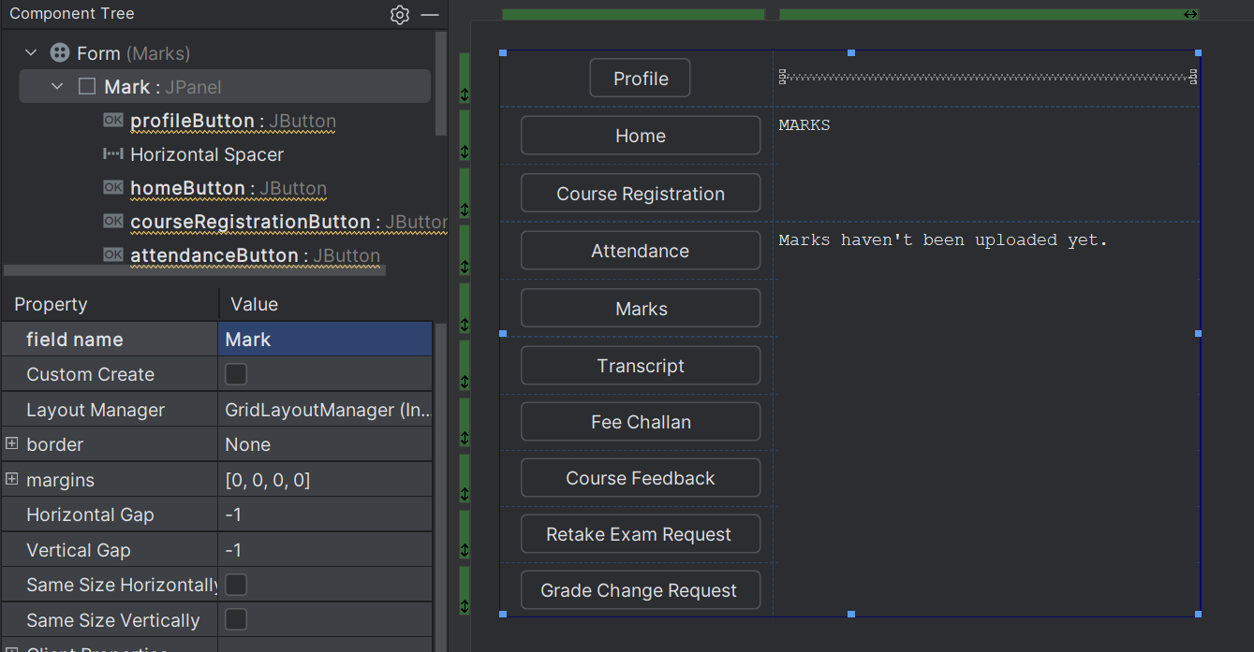

//Hafsa Salman  
//22K-5161  
//Task no. 06  
  
import javax.swing.*;  
import java.awt.event.ActionEvent;  
import java.awt.event.ActionListener;  
  
public class Transcript extends JFrame  
{  
 private JButton profileButton;  
 private JButton homeButton;  
 private JButton courseRegistrationButton;  
 private JButton attendanceButton;  
 private JButton marksButton;  
 private JButton transcriptButton;  
 private JButton feeChallanButton;  
 private JButton courseFeedbackButton;  
 private JButton retakeExamRequestButton;  
 private JButton gradeChangeRequestButton;  
 private JTextArea TRANSCRIPTTextArea;  
 private JTextArea FALL2024TextArea;  
 private JPanel Trans;  
  
 public Transcript()  
 {  
 homeButton.addActionListener(new ActionListener()  
 {  
 @Override  
 public void actionPerformed(ActionEvent e)  
 {  
 Home home = new Home();  
 home.Print();  
 dispose();  
 }  
 });  
  
 courseRegistrationButton.addActionListener(new ActionListener()  
 {  
 @Override  
 public void actionPerformed(ActionEvent e)  
 {  
 CourseRegistration courseRegistration = new CourseRegistration();  
 courseRegistration.Print();  
 dispose();  
 }  
 });  
  
  
 attendanceButton.addActionListener(new ActionListener()  
 {  
 @Override  
 public void actionPerformed(ActionEvent e)  
 {  
 Attendance attendance = new Attendance();  
 attendance.Print();  
 dispose();  
 }  
 });  
  
  
 marksButton.addActionListener(new ActionListener()  
 {  
 @Override  
 public void actionPerformed(ActionEvent e)  
 {  
 Marks marks = new Marks();  
 marks.Print();  
 dispose();  
 }  
 });  
  
  
 transcriptButton.addActionListener(new ActionListener()  
 {  
 @Override  
 public void actionPerformed(ActionEvent e)  
 {  
 Transcript transcript = new Transcript();  
 transcript.Print();  
 dispose();  
 }  
 });  
  
  
 feeChallanButton.addActionListener(new ActionListener()  
 {  
 @Override  
 public void actionPerformed(ActionEvent e)  
 {  
 FeeChallan feeChallan = new FeeChallan();  
 feeChallan.Print();  
 dispose();  
 }  
 });  
  
  
 courseFeedbackButton.addActionListener(new ActionListener()  
 {  
 @Override  
 public void actionPerformed(ActionEvent e)  
 {  
 CourseFeedback courseFeedback = new CourseFeedback();  
 courseFeedback.Print();  
 dispose();  
 }  
 });  
  
  
 retakeExamRequestButton.addActionListener(new ActionListener()  
 {  
 @Override  
 public void actionPerformed(ActionEvent e)  
 {  
 RetakeExamRequest retakeExamRequest = new RetakeExamRequest();  
 retakeExamRequest.Print();  
 dispose();  
 }  
 });  
  
  
 gradeChangeRequestButton.addActionListener(new ActionListener()  
 {  
 @Override  
 public void actionPerformed(ActionEvent e)  
 {  
 GradeChangeRequest gradeChangeRequest = new GradeChangeRequest();  
 gradeChangeRequest.Print();  
 dispose();  
 }  
 });  
 }  
  
 public void Print()  
 {  
 Transcript T6 = new Transcript();  
 T6.setContentPane(T6.Trans);  
 T6.setTitle("Transcript (22K-5161)");  
 T6.setSize(600, 700);  
 T6.setVisible(true);  
 T6.setDefaultCloseOperation(JFrame.*EXIT_ON_CLOSE*);  
 }  
  
 public static void main(String[] args)  
 {  
 Transcript T6 = new Transcript();  
  
 T6.setContentPane(T6.Trans);  
 T6.setTitle("Transcript (22K-5161)");  
 T6.setSize(600, 700);  
 T6.setVisible(true);  
  
 T6.setDefaultCloseOperation(JFrame.*EXIT_ON_CLOSE*);  
 }  
}

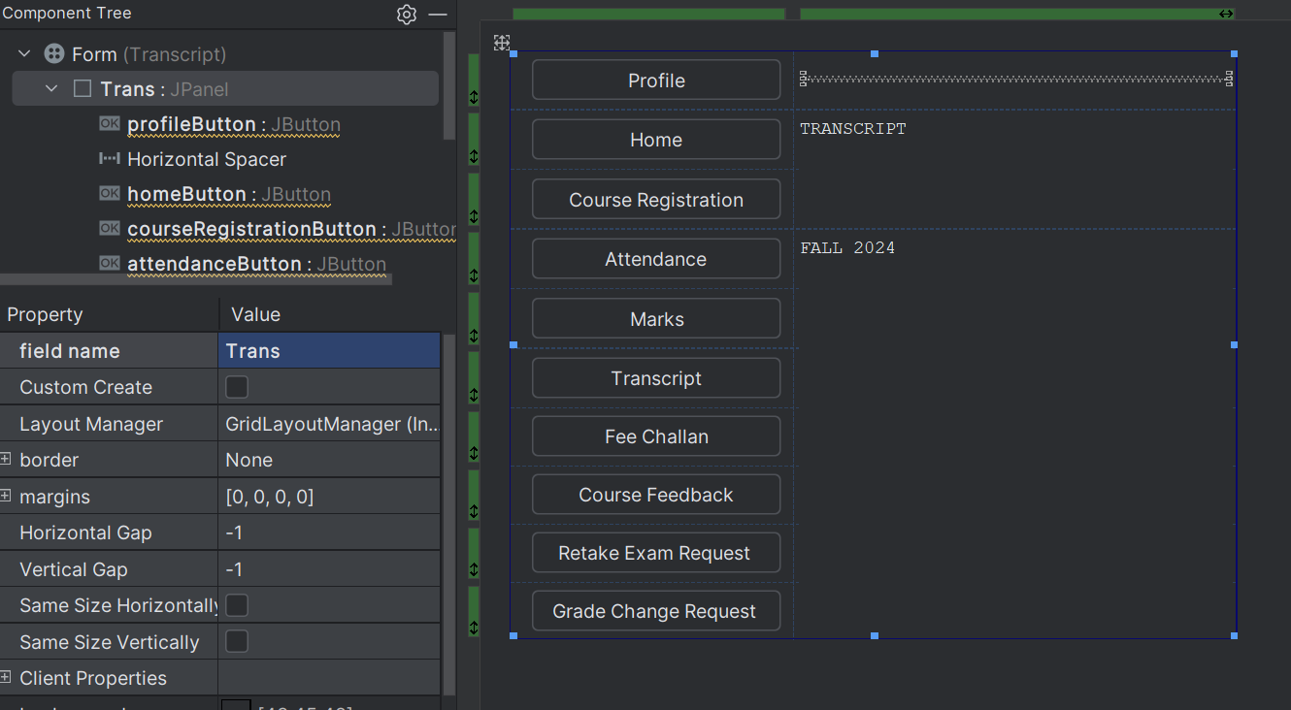

//Hafsa Salman  
//22K-5161  
//Task no. 06  
  
import javax.swing.*;  
import java.awt.event.ActionEvent;  
import java.awt.event.ActionListener;  
  
public class FeeChallan extends JFrame  
{  
 private JButton profileButton;  
 private JButton homeButton;  
 private JButton courseRegistrationButton;  
 private JButton attendanceButton;  
 private JButton marksButton;  
 private JButton transcriptButton;  
 private JButton feeChallanButton;  
 private JButton courseFeedbackButton;  
 private JButton retakeExamRequestButton;  
 private JButton gradeChangeRequestButton;  
 private JTextArea FEECHALLANTextArea;  
 private JTextArea feesHasAlreadyBeenTextArea;  
 private JPanel FeeC;  
  
 public FeeChallan()  
 {  
 homeButton.addActionListener(new ActionListener()  
 {  
 @Override  
 public void actionPerformed(ActionEvent e)  
 {  
 Home home = new Home();  
 home.Print();  
 dispose();  
 }  
 });  
  
 courseRegistrationButton.addActionListener(new ActionListener()  
 {  
 @Override  
 public void actionPerformed(ActionEvent e)  
 {  
 CourseRegistration courseRegistration = new CourseRegistration();  
 courseRegistration.Print();  
 dispose();  
 }  
 });  
  
  
 attendanceButton.addActionListener(new ActionListener()  
 {  
 @Override  
 public void actionPerformed(ActionEvent e)  
 {  
 Attendance attendance = new Attendance();  
 attendance.Print();  
 dispose();  
 }  
 });  
  
  
 marksButton.addActionListener(new ActionListener()  
 {  
 @Override  
 public void actionPerformed(ActionEvent e)  
 {  
 Marks marks = new Marks();  
 marks.Print();  
 dispose();  
 }  
 });  
  
  
 transcriptButton.addActionListener(new ActionListener()  
 {  
 @Override  
 public void actionPerformed(ActionEvent e)  
 {  
 Transcript transcript = new Transcript();  
 transcript.Print();  
 dispose();  
 }  
 });  
  
  
 feeChallanButton.addActionListener(new ActionListener()  
 {  
 @Override  
 public void actionPerformed(ActionEvent e)  
 {  
 FeeChallan feeChallan = new FeeChallan();  
 feeChallan.Print();  
 dispose();  
 }  
 });  
  
  
 courseFeedbackButton.addActionListener(new ActionListener()  
 {  
 @Override  
 public void actionPerformed(ActionEvent e)  
 {  
 CourseFeedback courseFeedback = new CourseFeedback();  
 courseFeedback.Print();  
 dispose();  
 }  
 });  
  
  
 retakeExamRequestButton.addActionListener(new ActionListener()  
 {  
 @Override  
 public void actionPerformed(ActionEvent e)  
 {  
 RetakeExamRequest retakeExamRequest = new RetakeExamRequest();  
 retakeExamRequest.Print();  
 dispose();  
 }  
 });  
  
  
 gradeChangeRequestButton.addActionListener(new ActionListener()  
 {  
 @Override  
 public void actionPerformed(ActionEvent e)  
 {  
 GradeChangeRequest gradeChangeRequest = new GradeChangeRequest();  
 gradeChangeRequest.Print();  
 dispose();  
 }  
 });  
 }  
  
 public void Print()  
 {  
 FeeChallan T6 = new FeeChallan();  
 T6.setContentPane(T6.FeeC);  
 T6.setTitle("Fee Challan (22K-5161)");  
 T6.setSize(600, 700);  
 T6.setVisible(true);  
 T6.setDefaultCloseOperation(JFrame.*EXIT_ON_CLOSE*);  
 }  
  
 public static void main(String[] args)  
 {  
 FeeChallan T6 = new FeeChallan();  
  
 T6.setContentPane(T6.FeeC);  
 T6.setTitle("FeeChallan (22K-5161)");  
 T6.setSize(600, 700);  
 T6.setVisible(true);  
  
 T6.setDefaultCloseOperation(JFrame.*EXIT_ON_CLOSE*);  
 }  
}

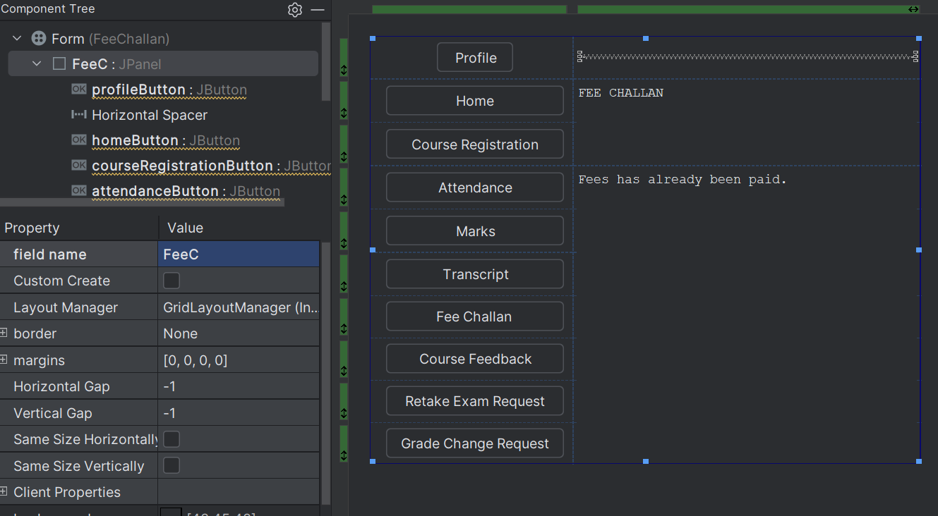

//Hafsa Salman  
//22K-5161  
//Task no. 06  
  
import javax.swing.*;  
import java.awt.event.ActionEvent;  
import java.awt.event.ActionListener;  
  
public class CourseFeedback extends JFrame  
{  
 private JButton profileButton;  
 private JButton homeButton;  
 private JButton courseRegistrationButton;  
 private JButton attendanceButton;  
 private JButton marksButton;  
 private JButton transcriptButton;  
 private JButton feeChallanButton;  
 private JButton courseFeedbackButton;  
 private JButton retakeExamRequestButton;  
 private JButton gradeChangeRequestButton;  
 private JTextArea COURSEFEEBACKTextArea;  
 private JTextArea courseFeedbackPeriodHasnTextArea;  
 private JPanel CFeed;  
  
 public CourseFeedback()  
 {  
 homeButton.addActionListener(new ActionListener()  
 {  
 @Override  
 public void actionPerformed(ActionEvent e)  
 {  
 Home home = new Home();  
 home.Print();  
 dispose();  
 }  
 });  
  
 courseRegistrationButton.addActionListener(new ActionListener()  
 {  
 @Override  
 public void actionPerformed(ActionEvent e)  
 {  
 CourseRegistration courseRegistration = new CourseRegistration();  
 courseRegistration.Print();  
 dispose();  
 }  
 });  
  
  
 attendanceButton.addActionListener(new ActionListener()  
 {  
 @Override  
 public void actionPerformed(ActionEvent e)  
 {  
 Attendance attendance = new Attendance();  
 attendance.Print();  
 dispose();  
 }  
 });  
  
  
 marksButton.addActionListener(new ActionListener()  
 {  
 @Override  
 public void actionPerformed(ActionEvent e)  
 {  
 Marks marks = new Marks();  
 marks.Print();  
 dispose();  
 }  
 });  
  
  
 transcriptButton.addActionListener(new ActionListener()  
 {  
 @Override  
 public void actionPerformed(ActionEvent e)  
 {  
 Transcript transcript = new Transcript();  
 transcript.Print();  
 dispose();  
 }  
 });  
  
  
 feeChallanButton.addActionListener(new ActionListener()  
 {  
 @Override  
 public void actionPerformed(ActionEvent e)  
 {  
 FeeChallan feeChallan = new FeeChallan();  
 feeChallan.Print();  
 dispose();  
 }  
 });  
  
  
 courseFeedbackButton.addActionListener(new ActionListener()  
 {  
 @Override  
 public void actionPerformed(ActionEvent e)  
 {  
 CourseFeedback courseFeedback = new CourseFeedback();  
 courseFeedback.Print();  
 dispose();  
 }  
 });  
  
  
 retakeExamRequestButton.addActionListener(new ActionListener()  
 {  
 @Override  
 public void actionPerformed(ActionEvent e)  
 {  
 RetakeExamRequest retakeExamRequest = new RetakeExamRequest();  
 retakeExamRequest.Print();  
 dispose();  
 }  
 });  
  
  
 gradeChangeRequestButton.addActionListener(new ActionListener()  
 {  
 @Override  
 public void actionPerformed(ActionEvent e)  
 {  
 GradeChangeRequest gradeChangeRequest = new GradeChangeRequest();  
 gradeChangeRequest.Print();  
 dispose();  
 }  
 });  
 }  
  
 public void Print()  
 {  
 CourseFeedback T6 = new CourseFeedback();  
 T6.setContentPane(T6.CFeed);  
 T6.setTitle("Course FeedBack (22K-5161)");  
 T6.setSize(600, 700);  
 T6.setVisible(true);  
 T6.setDefaultCloseOperation(JFrame.*EXIT_ON_CLOSE*);  
 }  
  
 public static void main(String[] args)  
 {  
 CourseFeedback T6 = new CourseFeedback();  
  
 T6.setContentPane(T6.CFeed);  
 T6.setTitle("Course Feedback (22K-5161)");  
 T6.setSize(600, 700);  
 T6.setVisible(true);  
  
 T6.setDefaultCloseOperation(JFrame.*EXIT_ON_CLOSE*);  
 }  
}

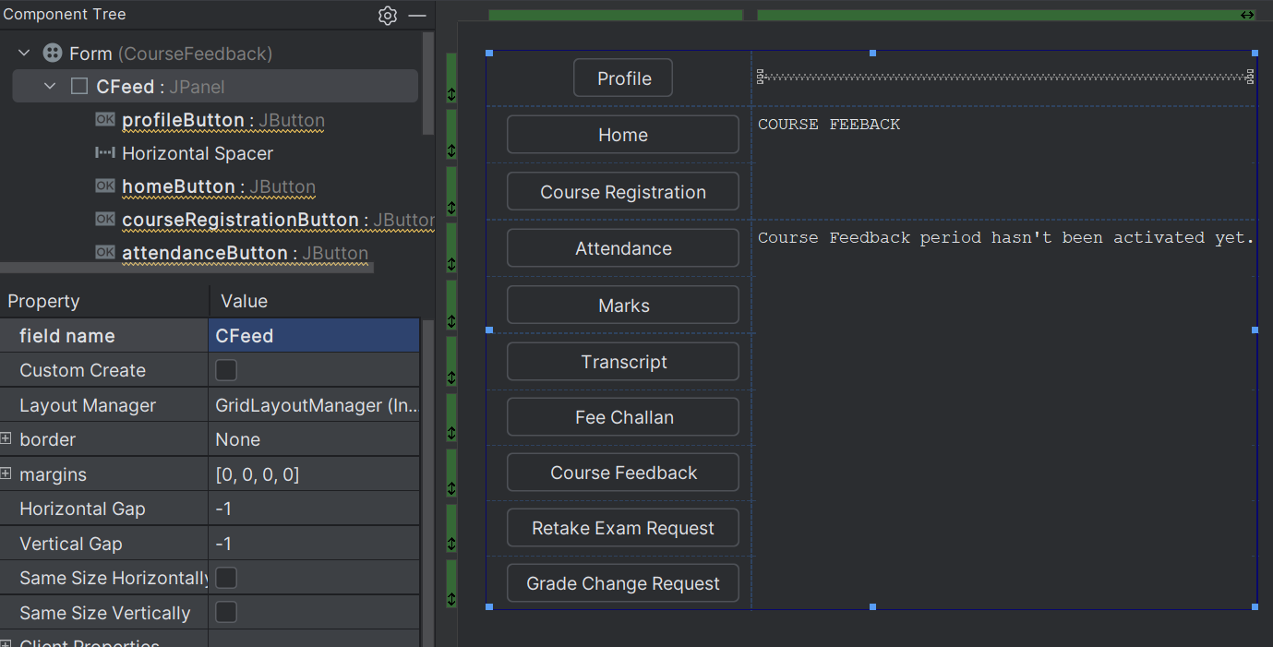

//Hafsa Salman  
//22K-5161  
//Task no. 06  
  
import javax.swing.*;  
import java.awt.event.ActionEvent;  
import java.awt.event.ActionListener;  
  
public class RetakeExamRequest extends JFrame  
{  
 private JButton profileButton;  
 private JButton homeButton;  
 private JButton courseRegistrationButton;  
 private JButton attendanceButton;  
 private JButton marksButton;  
 private JButton transcriptButton;  
 private JButton feeChallanButton;  
 private JButton courseFeedbackButton;  
 private JButton retakeExamRequestButton;  
 private JButton gradeChangeRequestButton;  
 private JTextArea RETAKEEXAMREQUESTTextArea;  
 private JTextArea thisPeriodHasnTTextArea;  
 private JPanel RER;  
  
 public RetakeExamRequest()  
 {  
 homeButton.addActionListener(new ActionListener()  
 {  
 @Override  
 public void actionPerformed(ActionEvent e)  
 {  
 Home home = new Home();  
 home.Print();  
 dispose();  
 }  
 });  
  
 courseRegistrationButton.addActionListener(new ActionListener()  
 {  
 @Override  
 public void actionPerformed(ActionEvent e)  
 {  
 CourseRegistration courseRegistration = new CourseRegistration();  
 courseRegistration.Print();  
 dispose();  
 }  
 });  
  
  
 attendanceButton.addActionListener(new ActionListener()  
 {  
 @Override  
 public void actionPerformed(ActionEvent e)  
 {  
 Attendance attendance = new Attendance();  
 attendance.Print();  
 dispose();  
 }  
 });  
  
  
 marksButton.addActionListener(new ActionListener()  
 {  
 @Override  
 public void actionPerformed(ActionEvent e)  
 {  
 Marks marks = new Marks();  
 marks.Print();  
 dispose();  
 }  
 });  
  
  
 transcriptButton.addActionListener(new ActionListener()  
 {  
 @Override  
 public void actionPerformed(ActionEvent e)  
 {  
 Transcript transcript = new Transcript();  
 transcript.Print();  
 dispose();  
 }  
 });  
  
  
 feeChallanButton.addActionListener(new ActionListener()  
 {  
 @Override  
 public void actionPerformed(ActionEvent e)  
 {  
 FeeChallan feeChallan = new FeeChallan();  
 feeChallan.Print();  
 dispose();  
 }  
 });  
  
  
 courseFeedbackButton.addActionListener(new ActionListener()  
 {  
 @Override  
 public void actionPerformed(ActionEvent e)  
 {  
 CourseFeedback courseFeedback = new CourseFeedback();  
 courseFeedback.Print();  
 dispose();  
 }  
 });  
  
  
 retakeExamRequestButton.addActionListener(new ActionListener()  
 {  
 @Override  
 public void actionPerformed(ActionEvent e)  
 {  
 RetakeExamRequest retakeExamRequest = new RetakeExamRequest();  
 retakeExamRequest.Print();  
 dispose();  
 }  
 });  
  
  
 gradeChangeRequestButton.addActionListener(new ActionListener()  
 {  
 @Override  
 public void actionPerformed(ActionEvent e)  
 {  
 GradeChangeRequest gradeChangeRequest = new GradeChangeRequest();  
 gradeChangeRequest.Print();  
 dispose();  
 }  
 });  
 }  
  
 public void Print()  
 {  
 RetakeExamRequest T6 = new RetakeExamRequest();  
 T6.setContentPane(T6.RER);  
 T6.setTitle("Retake Exam Request (22K-5161)");  
 T6.setSize(600, 700);  
 T6.setVisible(true);  
 T6.setDefaultCloseOperation(JFrame.*EXIT_ON_CLOSE*);  
 }  
  
 public static void main(String[] args)  
 {  
 RetakeExamRequest T6 = new RetakeExamRequest();  
  
 T6.setContentPane(T6.RER);  
 T6.setTitle("Retake Exam Request (22K-5161)");  
 T6.setSize(600, 700);  
 T6.setVisible(true);  
  
 T6.setDefaultCloseOperation(JFrame.*EXIT_ON_CLOSE*);  
 }  
}

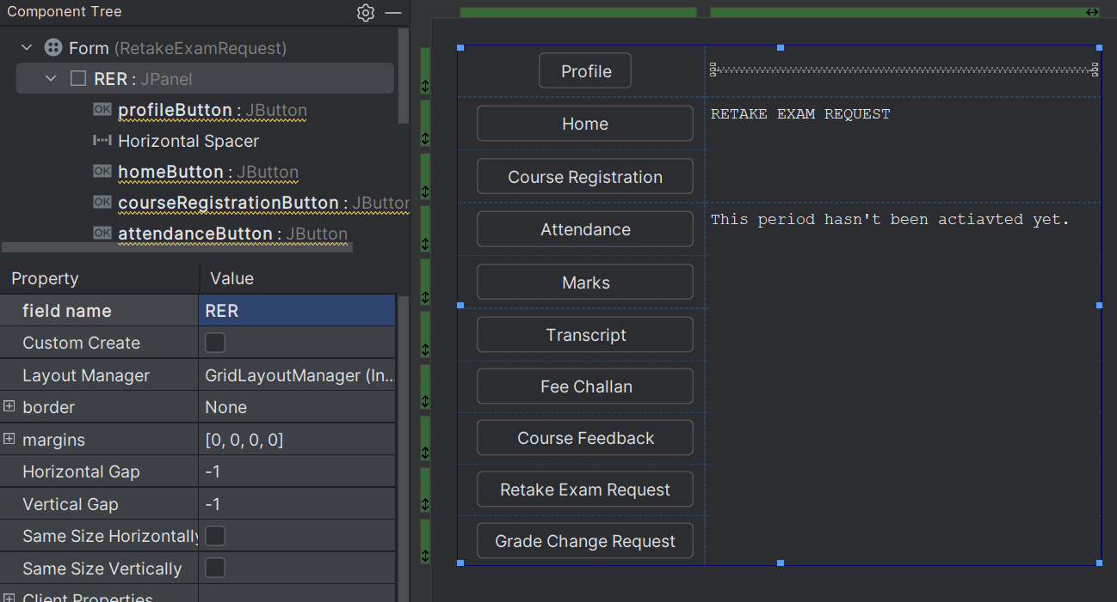

//Hafsa Salman  
//22K-5161  
//Task no. 06  
  
import javax.swing.*;  
import java.awt.event.ActionEvent;  
import java.awt.event.ActionListener;  
  
public class GradeChangeRequest extends JFrame  
{  
 private JButton profileButton;  
 private JButton homeButton;  
 private JButton courseRegistrationButton;  
 private JButton attendanceButton;  
 private JButton marksButton;  
 private JButton transcriptButton;  
 private JButton courseFeedbackButton;  
 private JButton feeChallanButton;  
 private JButton courseFeedbackButton1;  
 private JButton retakeExamRequestButton;  
 private JButton gradeChangeRequestButton;  
 private JTextArea GRADECHANGEREQUESTTextArea;  
 private JTextArea thisPeriodHasnTTextArea;  
 private JPanel GCR;  
  
 public GradeChangeRequest()  
 {  
 homeButton.addActionListener(new ActionListener()  
 {  
 @Override  
 public void actionPerformed(ActionEvent e)  
 {  
 Home home = new Home();  
 home.Print();  
 dispose();  
 }  
 });  
  
 courseRegistrationButton.addActionListener(new ActionListener()  
 {  
 @Override  
 public void actionPerformed(ActionEvent e)  
 {  
 CourseRegistration courseRegistration = new CourseRegistration();  
 courseRegistration.Print();  
 dispose();  
 }  
 });  
  
  
 attendanceButton.addActionListener(new ActionListener()  
 {  
 @Override  
 public void actionPerformed(ActionEvent e)  
 {  
 Attendance attendance = new Attendance();  
 attendance.Print();  
 dispose();  
 }  
 });  
  
  
 marksButton.addActionListener(new ActionListener()  
 {  
 @Override  
 public void actionPerformed(ActionEvent e)  
 {  
 Marks marks = new Marks();  
 marks.Print();  
 dispose();  
 }  
 });  
  
  
 transcriptButton.addActionListener(new ActionListener()  
 {  
 @Override  
 public void actionPerformed(ActionEvent e)  
 {  
 Transcript transcript = new Transcript();  
 transcript.Print();  
 dispose();  
 }  
 });  
  
  
 feeChallanButton.addActionListener(new ActionListener()  
 {  
 @Override  
 public void actionPerformed(ActionEvent e)  
 {  
 FeeChallan feeChallan = new FeeChallan();  
 feeChallan.Print();  
 dispose();  
 }  
 });  
  
  
 courseFeedbackButton.addActionListener(new ActionListener()  
 {  
 @Override  
 public void actionPerformed(ActionEvent e)  
 {  
 CourseFeedback courseFeedback = new CourseFeedback();  
 courseFeedback.Print();  
 dispose();  
 }  
 });  
  
  
 retakeExamRequestButton.addActionListener(new ActionListener()  
 {  
 @Override  
 public void actionPerformed(ActionEvent e)  
 {  
 RetakeExamRequest retakeExamRequest = new RetakeExamRequest();  
 retakeExamRequest.Print();  
 dispose();  
 }  
 });  
  
  
 gradeChangeRequestButton.addActionListener(new ActionListener()  
 {  
 @Override  
 public void actionPerformed(ActionEvent e)  
 {  
 GradeChangeRequest gradeChangeRequest = new GradeChangeRequest();  
 gradeChangeRequest.Print();  
 dispose();  
 }  
 });  
 }  
  
 public void Print()  
 {  
 GradeChangeRequest T6 = new GradeChangeRequest();  
 T6.setContentPane(T6.GCR);  
 T6.setTitle("HomePage (22K-5161)");  
 T6.setSize(600, 700);  
 T6.setVisible(true);  
 T6.setDefaultCloseOperation(JFrame.*EXIT_ON_CLOSE*);  
 }  
  
 public static void main(String[] args)  
 {  
 GradeChangeRequest T6 = new GradeChangeRequest();  
  
 T6.setContentPane(T6.GCR);  
 T6.setTitle("Grade Change Request (22K-5161)");  
 T6.setSize(600, 700);  
 T6.setVisible(true);  
  
 T6.setDefaultCloseOperation(JFrame.*EXIT_ON_CLOSE*);  
 }  
}

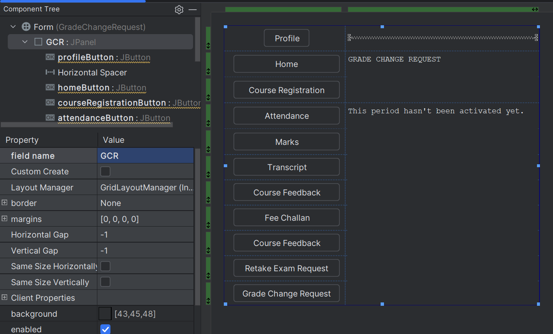

Output:



